Chinese stem cell breakthrough a boon for regrowing damaged muscles
By Jayalakshmi K June 13, 2015 08:43 BST

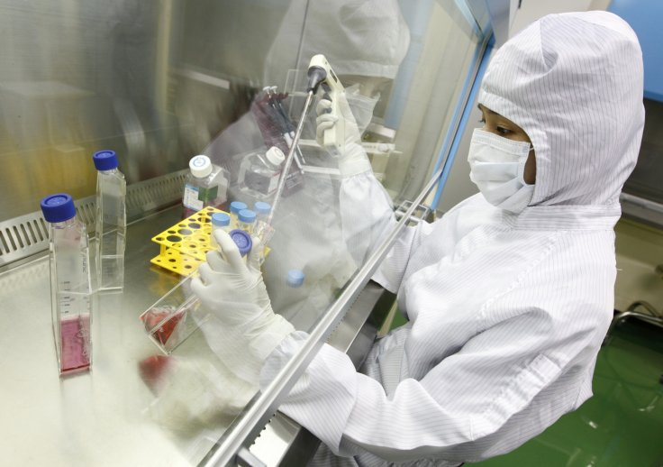
The key to growing a healthy population of stem cells in the lab was in finding the proteins that best stimulate growth in lab from a list of 10,000 possible candidate proteins. The team narrowed the list down to four proteins.
Muscle stem cells grown in large numbers in lab by Chinese researchers could help athletes and those with muscle-related injuries grow new muscles.
Muscles do not heal easily on their own and if a patient loses more than 20% of a muscle tissue in any area, the damage is permanent with no cure available till now.
The stem cell breakthrough could help in such situations as also ALS patients and those who have undergone cancer surgery, said Hu Ping, cell biologist at the Shanghai Institute for Biological Science at the Chinese Academy of Sciences.
"It can generate enough stem cells to heal permanent wounds, especially those caused externally," she told the South China Morning Post.
The findings are published in the latest issue of the journal Cell Research.
Research across the world has been trying to grow sufficient numbers of stem cells but faces problems in coaxing the cells to divide under lab conditions.
The growth factors to simulate growth have been difficult to pin down.
In many instances, the cells lost their viability after transplantation.
Hu's team managed to harvest 10 trillion muscle stem cells from a pool of just 10,000 original stem cells taken from the host. The new versions were almost as effective as the originals in terms of regenerating muscle.
The key was in finding the proteins that best stimulate growth in lab from a list of 10,000 possible candidate proteins, Hu said.
The team narrowed down the list to four proteins.
Although the tests on mice showed that the test tube-generated cells were almost identical to the natural cells, extensive clinical trials will be needed to check for side-effects before use in humans.
Stem cells have been seen to undergo mutations that could lead to tumours.
Even though the cells can be extracted from healthy muscles fairly easily, big wounds require large numbers to be removed from healthy parts of the patient's body, posing a risk. Instead, stem cells grown in lab could be a safer bet.
Lack of volunteers
The team has contacted hospitals in China about conducting human trials but has struggled to find volunteers, partly due to financing and partly because the Chinese are less interested in sport than people in Western countries, Hu said.
Stem cells are the body's growth and maintenance units that are able to differentiate indefinitely into specialised cell types, first in the growing embryo into various organ cell types, and later form the body's repair mechanism by producing cells when the tissue they reside in is damaged.
These stem cells are found in most tissue types as well as in the embryo. The most useful stem cells are those derived from embryos known as "pluripotent" stem cells as they can differentiate into any cell type in the body.
Adult stem cells are known as multipotent stem cells but they are not as flexible as embryonic stem cells do, though they can be coaxed to differentiate into lots of useful cell types.

